电子信誉评估系统
徐政辉
¹(浙江理工大学 计算机科学与技术,浙江 杭州 310018)

Electronic reputation evaluation system
Zhenghui Xu¹⁺
¹(Department of Computer Science and Technology, Zhejiang Sci-tech University, Hangzhou Zhejiang 310018, China)
Abstract: China ’s credit information system has been continuously developed in recent years, especially in the Internet industry. The electronic credit information system has been well-developed under the leadership of major Internet giants and has continuously promoted the construction of the Internet. With the continuous improvement of the credit information system, the credit information dimension has not been improved, and problems such as imperfect credit information are still outstanding. The future credit information system should be more suitable for personal life, increase the evaluation dimension, and combine with the evaluation system of artificial intelligence. We first propose six evaluation criteria and an AI-assisted method, and then explain in detail the overall evaluation system we propose, and supplement it with personal experience.
Key words: reputation; evaluation; loan repayment; assets; artificial intelligence
摘 要: 我国的征信体系在最近几年得到不断的发展，尤其是互联网产业方面，电子信誉征信系统由各大互联网巨头的带领下，得到了很好的发展，也不断推进了互联网的建设，但伴随着征信体系的不断改进，征信维度并没有得到提高，征信信息不完善等问题仍然突出。未来的征信体系，应当更贴合个人的生活，增加评估维度，并结合人工智能的评估体系。我们先提出六个评价标准及一个AI辅助方法，然后对我们提出的总体评价体系进行详细讲解，并结合个人经历进行补充说明。
关键词: 信誉;评价;偿贷;资产;人工智能

Introduction
In the uncertain electronic commerce market², personal electronic reputation judgment has become an important standard and basis for loans, consumption, transactions, and decision-making. The rapid development of the Internet now leads us to a new trend of online consumption, trading and decision-making. Under such environmental and social conditions, we have to consider how to make a good judgment of the other party's reputation and other factors in the face of unreliable information. In today's state, artificial intelligence technology continues to develop and the "artificial intelligence +" industry continues to advance. We need to consider the new electronic reputation system combined with the excellent characteristics of artificial intelligence to assist in the establishment of models. The future is bound to be an era in which artificial intelligence knows the development of the industry. We must combine its superior technologies in this process to maximize our production, trading, consumption, loan benefits and standardization. Today, e-commerce giants such as Alibaba, Tencent, JD.com, and Amazon have made full and sound theoretical implementations and specific practices of their own e-commerce evaluation systems. It is necessary for us to learn from its useful experience by reference, and it is also necessary to analyze its shortcomings and existing problems to establish a new electronic reputation evaluation system. At present, enterprise-level credit information systems are usually too commercialized, and government reputation systems are too conservative, and have adopted a stable reputation evaluation system that has been in use, but on some levels, it has a certain degree of backwardness. Sex. With the continuous development of the times, in the future, we urgently need a new electronic reputation system to realize trade, loans, and decision-making under the reputation evaluation standards based on standardization, independence, and fairness among individuals, enterprises, governments, and countries. Under such circumstances, we propose the following multi-dimensional reputation evaluation model and basic standards to respond to social needs and to meet user and corporate behavioral decision-making needs.

Reputation evaluation criteria

Working status
Work is a guarantee for a person ’s asset stability, and the working status can evaluate the individual ’s stable salary status for a period of time in the future, thereby evaluating the individual ’s ability to repay in the future. We usually use this to measure a person's future solvency level, which is an important part of reputation assessment. For example, the student group, because there is no stable job, that is, there is no real stable economic income, so its repayable loan capacity is very weak compared to an adult who has worked, and we have a basic reputation under preliminary judgment. Is weaker. Of course, this is only a part of the judging criteria, and therefore cannot completely judge a person's credit level and ability.

Reputation assessment status of those around you
A person's reputation status is not only related to himself, but also to his environment, the reputation of his family and friends. In layman's terms, if the family has a large number of loans that are overdue, there will inevitably be pressure on the individual to repay, and the individual's ability to repay will shrink in the middle, because part of it becomes extra Repayment. This evaluation example is also included in friends and the environment. Here we also consider the possibility of borrowing on behalf of others with the help of a higher credit status. We abstractly define it as: credit lending, that is, people with high credibility help people with low credit lending through their credit. In this case, what needs to be evaluated is the borrowing level of people with low creditworthiness, that is, we consider the borrowing level of people around us as a personal borrowing level assessment option. This part guarantees the environmental factors of borrowers' borrowing and reduces the occurrence of false borrowing and transfer of borrowing. You can also better assess a person's credibility. On the other hand, the existence of high-reputation groups in the environment will also improve the repayment ability of individuals, which mainly considers that individuals will seek loans from high-reputation people for help. As a result, his personal borrowing level will also increase by a corresponding factor.

Asset valuation
Reputation level is also related to personal assets. People with high assets have relatively higher repayment ability and also have wider income and expenditure channels. We regard asset level as one of the criteria for reputation evaluation. Those with high assets usually have more flexible methods of controlling the amount of money. Compared with those with low assets, they have better ability to repay loans. But this is not absolute, we just use it as part of the judging criteria. Correspondingly, those with low assets have relatively lower solvency. Here we show that our loan repayment capacity estimation is non-relative, and the judgment is the absolute repayment amount. High assets can repay more, and low assets can repay less. That is, those with low assets will have relatively lower credit ratings than those with high assets. We also found such a problem here, sometimes high assets have higher credit rating points than those with low assets. But this is reasonable, because the amount of repayment does have a high or low division for people with different asset levels. We are here to explain that our introduction does not exist discrimination and prejudice, only to make objective assumptions and agreements based on the prevailing phenomenon.

Consumption record ability
The level of consumption is also within the scope of the assessment, usually the level of consumption reflects a person's credibility level from the side. Through consumption records, one can assess a person's propensity to consume from different consumption dimensions, thereby judging the value generated by the consumption directed by the individual's consumption intention. For example, those who tend to invest, appreciate and buy, and purchase knowledge to increase their personal competence level will promote the individual's potential ability and value enhancement, which will increase the credibility level to a certain extent. In addition, those with high consumption frequency, timely repayment ability, and higher credibility level, this and the next point of repayment ability have an intersection, so I won't repeat them here.

The ability to repay the loan (record of loan repayment)
An assessment of the loan repayment record can obtain a person's ability to repay the loan in a timely manner. This is the main and important point of assessing a person's credibility. Those with strong repayment ability and able to keep their promises every time generally have a higher level of credibility. We provide a higher reputation value for this, and we occupy a large proportion of this, which is also a high standard for measuring good reputation (under the constraint of relative repayment capacity). We often see some people failing to repay their loans after the due date. In terms of life, some people default on bank loans. They are rated as Lao Lai and are classified as untrustworthy. Of course, these are people who have defaulted on loans and have low creditworthiness. A good application is Alipay. In today's era of developed Internet, we often use Alipay for online payment shopping. Alipay has the function of chanting, and we can borrow the amount of money for early consumption and pay off in the writing month. This will also record sesame credits. The specific credit information system will be described later. Here, we mentioned a case where the flowers are not paid next month. At this time, users will be reduced to the credit score of sesame seeds, that is, they are in a state of dishonesty. This is an example of judging the good personal credit reputation by repayment records.

Trustworthiness of banking business
Generally, personal bank lending information is already a good judgment standard, and the previous bank credit information system has been well developed. We can apply the individual's credit rating in major banks and attach it to the current judgment standards, which not only protects the reputation evaluation value on the basis of the original fully mature value, but also combines a new multi-dimensional system, which can make The credit information system is more perfect and suitable for the reality of life. It also guarantees that the reputation level measurement generated in this way has a certain initial value basis.

Using artificial intelligence
Artificial intelligence has been widely used in all walks of life in today's society. Here we propose Fangfa, which uses artificial intelligence technology to help us predict credibility. We aim to output the credibility level of a person in the current state by inputting some specific state of the person. As part of our reference for evaluating the credibility level (we will use it as a reference here, and not integrated into the real prediction system, because the model has uncertainty and its parallel relationship with the real situation, we will express in the following chart Out of this relationship).

Brief description of the current mature reputation evaluation system
We mainly introduce Alibaba's "Sesame Credit" credit reporting system. Sesame Credit is based on the FICO scoring system, and through cloud computing analysis to obtain ratings, preferences, interpersonal, identity, performance five indicators, to evaluate credit. Sesame Credit relies on the Alipay platform to collect a large amount of data, which has the characteristics of wide data sources and high timeliness of data. Therefore, Sesame Credit has an advantage over ordinary evaluation standards under this scoring system. However, Sesame Credit, as a system created by profit-making organizations, has a tendency to make profits. Therefore, credibility evaluation will not be as completely independent and impartial as that of central banks and other national institutions as a credit evaluation system. We view this dialectically and also propose a new evaluation system as an effective reference for us below.¹
FICO was originally FAIR, Isaac and Company, a data analysis company based in San Jose, California, focusing on credit scoring services. Its FICO score has become an important indicator of American consumer loans. The following figure (picture source: https://en.wikipedia.org/wiki/FICO) reflects the proportion of its various evaluation standards. It can be seen that the payment history and the total number of assets owned account for the total evaluation system The proportion of 65% shows that these two proportions of the evaluation criteria are quite large.
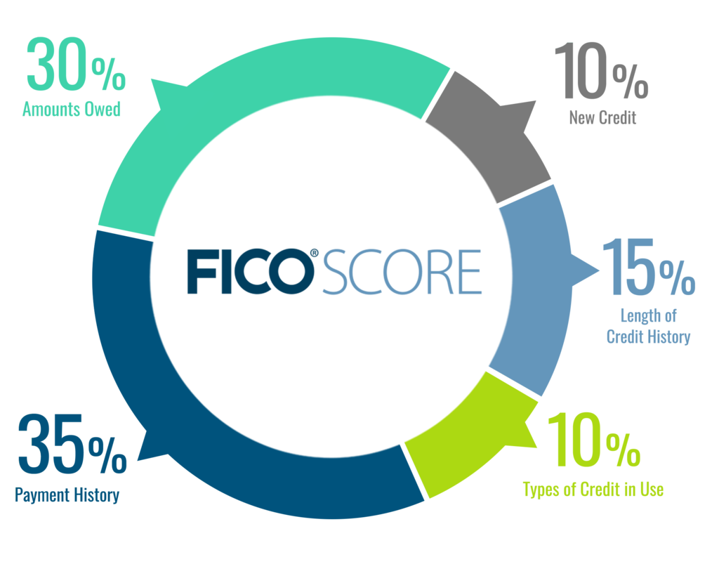

Multi-dimensional model proposed
As shown in the figure below, based on the six dimensions of the evaluation criteria, we arrive at a reputation level calculation model with the following structure. We initially assigned six evaluation criteria with a weight ratio of 5%, 5%, 30%, 10%, 30%, and 20%. These are references to the basic values ​​of the FICO model impact factor model. We will use the artificial intelligence intensive training and neural network training Fangfa to fine-tune the weight ratio to achieve a more reasonable and accurate evaluation value (as shown by the light dotted dotted line in the following figure), and we input the state information into human-based experience In the evaluation model, the evaluation result of the relevant model is calculated through the formula. From another branch (shown by the dotted line in the figure), we use neural network evaluation to obtain the evaluation value of the auxiliary reference, and give back to the human experience evaluation for reference, and finally add some optional business personnel to intervene and evaluate, and get the final score. We then feed back the scoring results to the neural network and train the model again as a data set to achieve the best output. The neural network model and scoring formula will be given in a new paper. The neural network structure is a basic model, which processes input data in a unified manner. After different output structures, it is divided into two independent models that output reputation evaluation values ​​and weight evaluation values, respectively, as the reputation evaluation reference model and update reputation evaluation standard weights. Than the fine-tuning model.
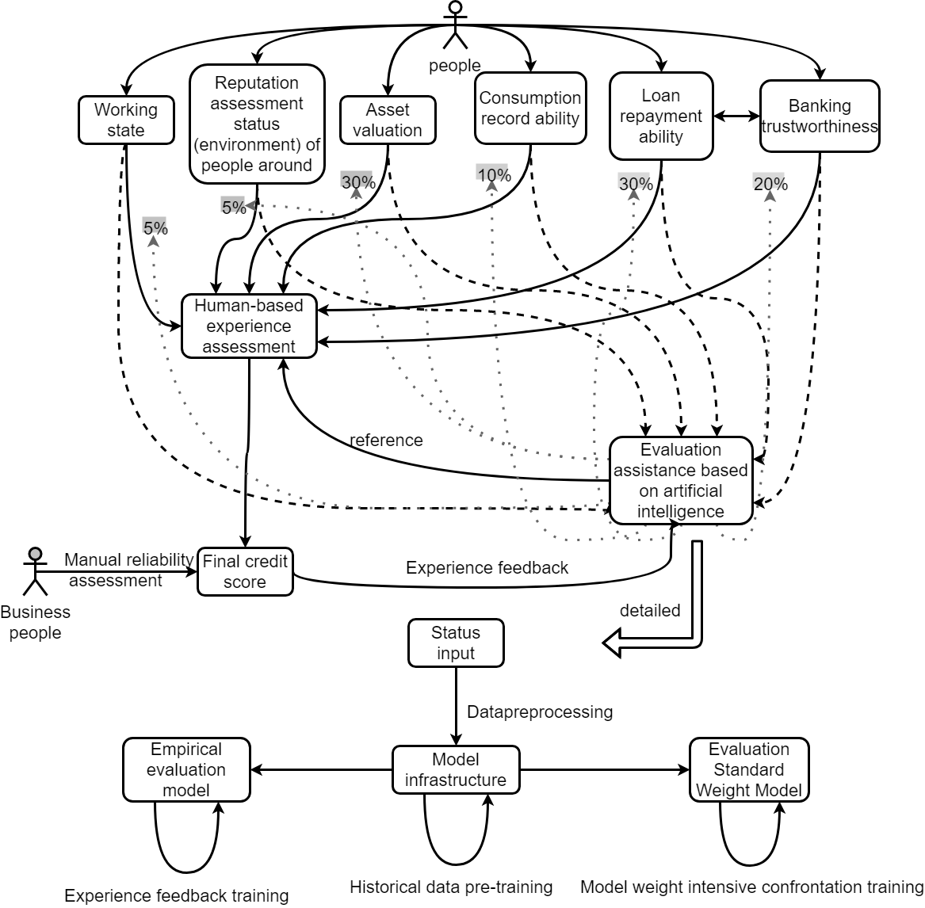

Brief description of life experience
The above model is proposed, which comes from personal life experience and investigation and collection of common behavioral phenomena of the masses. For example, the loan-driven purpose of the people around you, loan consumption in life is personally seen, mainly divided into the following types, debt loans, advance consumption loans, investment loans, cash flow loans, housing loans, etc. Our evaluation model should distinguish between these types of loans to meet the actual situation and make more accurate evaluation results. And for people with different identities, they usually have different consumption tendencies and reputation levels. Usually in life, people with different wealth will have different consumption base amount and consumption tendency and loan amount, we should take this into consideration and make a distinction. Of course, wealth cannot absolutely judge a person's credibility. Credibility is based on a person's moral level and potential educational relationship. In life, you usually need to use credit to maintain certain benefits of consumption, production, and business, such as online stores on Taobao, JD.com, and other real-life physical stores. Improve your credibility and the group relevance of the surrounding people to increase your own marketing. Therefore, our evaluation of this always takes into account the impact of the surrounding environment, which is also taken into account in our model. Generally, at this stage, younger groups are more inclined to online electronic consumption, with different forms of consumption and different consumption volumes, while older groups still generally use cash consumption and physical consumption. We also give different considerations to people with different identities. We integrate this into the criteria for judging work status. In life, our evaluation of a person ’s credibility is not based on the judgment of a person ’s one-time trading behavior, but a long-term trading behavior. We have drawn many times and long-term cooperation and behaviors for this person. For the evaluation of credibility, we therefore cannot consider the credibility evaluation of individual data alone. We consider the credibility of people under different circumstances over time. Therefore, in the proposed neural network model, we will use the LSTM model (long and short-term memory model) to evaluate the continuity of the past and present. Through the summary of the above part of life experience, we combined it into our proposed model, and effectively strengthened the reliability of the model.

Summary
According to the existing dominant model, combined with human moral judgment, and relying on the assistance of modern artificial intelligence technology, we have proposed the above multi-dimensional electronic reputation evaluation model, and elaborated on it. Consumer propensity and loan propensity to better summarize the model concept. It is hoped that with this model, a more professional model framework will be established and applied to the future real credibility assessment to provide companies, individuals and governments with more reliable, reliable and stable credibility assessment standards.

References:
[1] 许凌锋.我国互联网征信体系分析探讨——以芝麻信用为例[J].现代营销(下旬刊),2020(03):50-51.
[2] 纪淑娴.基于成本收益的用户参与在线信誉反馈系统驱动力研究[J].软科学,2014,28(03):114-118.

